**DAILY ONLINE ACTIVITIES SUMMARY**

|  |  |  |  |  |  |  |  |
| --- | --- | --- | --- | --- | --- | --- | --- |
| **Date:** | **14-07-2020** | | | | **Name:** | **B.A.SOHANKUMAR** | |
| **Sem & Sec** | **4TH SEM A** | | | | **USN:** | **4AL18CS013** | |
| **Online Test Summary** | | | | | | | |
| **Subject** | | **----** | | | | | |
| **Max. Marks** | | **----** | | **Score** | | **----** | |
| **Certification Course Summary** | | | | | | | |
| **Course** | **ADVANCED STATISTICS FOR MACHINE LEARNING** | | | | | | |
| **Certificate Provider** | | | **GLA** | **Duration** | | | **5.5 HOURS** |
| **Coding Challenges** | | | | | | | |
| **Problem Statement:1:Write a java program to check for balanced parenthesis .** | | | | | | | |
| **Status: DONE** | | | | | | | |
| **Uploaded the report in Github** | | | | **YES** | | | |
| **If yes Repository name** | | | | **https://github.com/sohannaik5648987/DAILY-REPORTS** | | | |
| **Uploaded the report in slack** | | | | **YES** | | | |

**CERTIFICATION COURSE DETAILS:**

Course: ADVANCED STATISTICS FOR MACHINE LEARNING

Today I have opted this new course and this course has a video content of 5.5 hours and 1 assessment quiz.Completed modules today are Overview of the course,Foundations of Statistics,Concept of Standard error and Probability,Practice questions on Probablity,Rules of Probability,Questions on Probability,Normal Distribution,Hands-on exercise on Normality distribution.

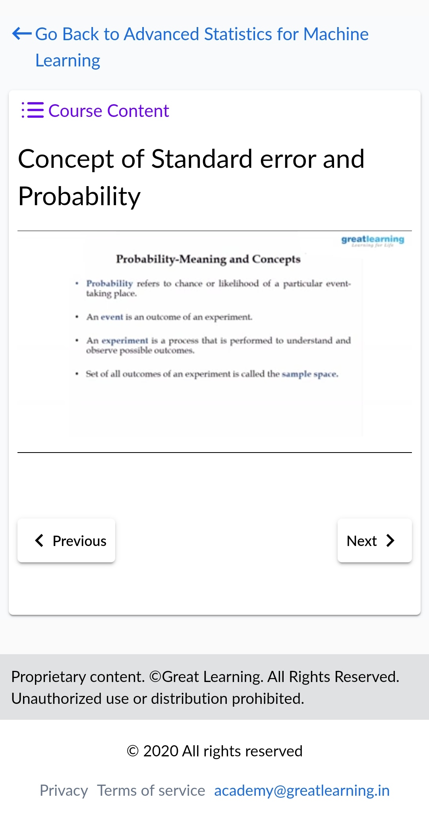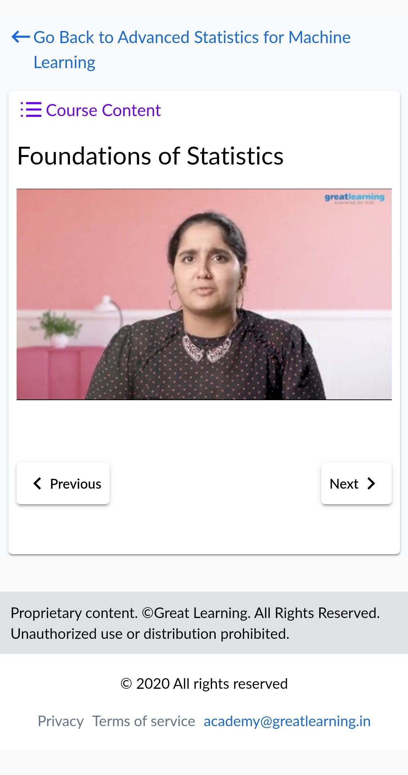

**CODING CHALLENGES:**

1. Write a java program to check for balanced parenthesis.Given an expression string exp. Examine whether the pairs and the orders of “{“,”}”,”(“,”)”,”[“,”]” are correct in exp.

For example, the program should print 'balanced' for exp = “[()]{}{()()}” and 'not balanced' for exp = “[(])”

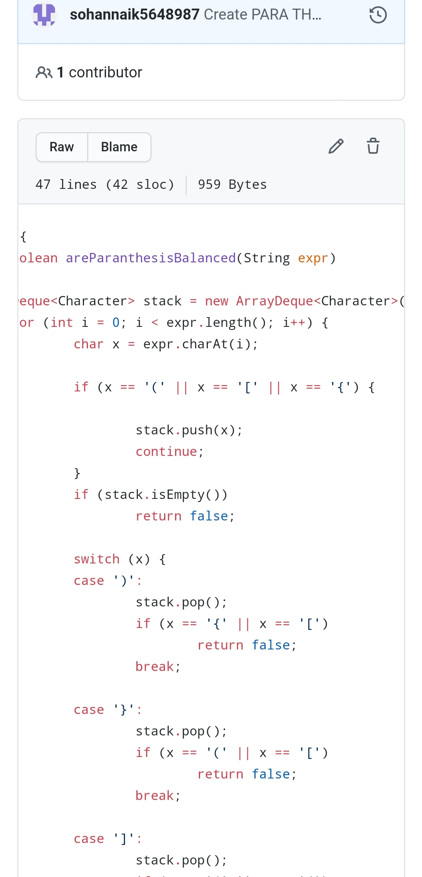

REPOSITORY LINK:https://github.com/sohannaik5648987/JAVA-CODING